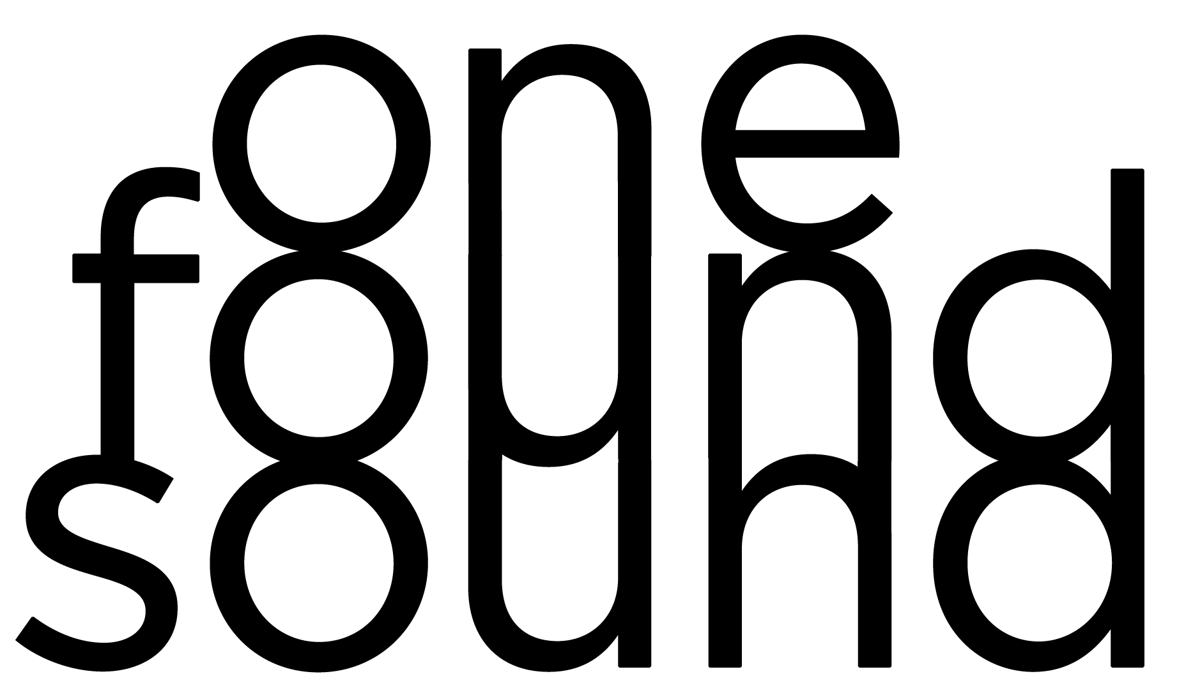

ONE FOUND SOUND 2022-2023 SEASON AT A GLANCE
Updated December 1, 2022

DREAM

Saturday, October 8, 2022 at 8:00 PM
Heron Arts, 7 Heron Street, San Francisco, CA 94103
IGOR STRAVINSKY - Concerto in E-flat major, “Dumbarton Oaks”
HANNAH KENDALL - Vera
BÉLA BARTÓK - Divertimento for Strings
ELEANOR ALBERGA - Sun Warrior

Featuring immersive visuals by filmmaker Max Savage in collaboration with Yuito Kimura.

FORMATION

Saturday, November 12, 2022 at 8:00 PM
Heron Arts, 7 Heron Street, San Francisco, CA 94103
ESTEVAN OLMOS - Mi Cultura Lejana [World Premiere; Winner of One Found Sound’s 2022 Emerging Composer Award]
DMITRI SHOSTAKOVICH - Chamber Symphony in C minor, Op. 110a (arr. Rudolf Barshai)
GABRIELA LENA FRANK - Elegía Andina
MICHAEL GILBERTSON - Graffiti: Concerto for Chamber Orchestra

Featuring immersive visuals by filmmaker Max Savage in collaboration with Dr. Rek and Subset.

HOLIDAY POP ROX!
Saturday, December 10, 2022 at 8:00 PM
Swedish American Hall, 2174 Market St, San Francisco, CA 94114

Hosted by Jesse Barrett with appearances by drag performers Nicki Jizz and Obsidienne Obsurd. Featuring a variety of holiday pop and classical music.

Featuring immersive visuals by filmmaker Max Savage.

HORIZON

Saturday, March 4, 2023 at 8:00 PM
Heron Arts, 7 Heron Street, San Francisco, CA 94103
LUDWIG VAN BEETHOVEN - Coriolan Overture, Op. 62
QUINN MASON - Reflection on a Memorial
HERBERT FRANKLIN MELLS - Symphony No. 1 in D Minor [World Premiere]

Featuring immersive visuals by filmmaker Max Savage.

TENTH BIRTHDAY BASH GALA

Saturday, May 13, 2023 at 8:00 PM
Heron Arts, 7 Heron Street, San Francisco, CA 94103
ANGÉLICA NEGRÓN - What Keeps Me Awake
NOKUTHULA NGWENYAMA - Primal Message
RUTH GIPPS - Seascape, Op. 53
NATHALIE JOACHIM – (Currently Untitled) [World Premiere; One Found Sound Commission]
Featuring immersive visuals by filmmaker Max Savage.

TICKET INFORMATION
Tickets are $25 online and available online at onefoundsound.org.
Gala tickets range from $45 - $125 and will be available later this season.

# # #

Press Contact: Georgeanne Banker
georgeanne@onefoundsound.org
onefoundsound.org/press

